Characterisation of modified hydrogels: their mechanical properties and human fibroblasts migration.
Renata Kazakova

Tabl.1. The Dynamic storage modulus (G’) and dynamic loss modulus (G’’) of photo hydrogel with PE 240, Methyluracil, Lecithin, PEI-M2. Oscillating frequency sweep test values are mean n=3, error bars represent S.D.

 | G' PE 240 |  | G' Methyluracil |  | G' PEI-M2 |  | G' Lecithin
f in Hz | MEAN | SD | MEAN | SD | MEAN | SD | MEAN | SD
1,00 | 1461,67 | 76,39 | 1379,12 | 356,09 | 1604,47 | 258,30 | 1180,40 | 267,77
1,47 | 1409,40 | 73,83 | 1504,65 | 158,12 | 1554,65 | 230,92 | 1185,91 | 317,65
2,15 | 1402,14 | 81,37 | 1481,82 | 152,43 | 1529,59 | 232,52 | 1174,81 | 312,65
3,16 | 1399,96 | 77,81 | 1468,10 | 139,07 | 1517,27 | 235,23 | 1167,11 | 310,67
4,64 | 1406,44 | 83,61 | 1464,97 | 134,75 | 1523,82 | 232,69 | 1173,22 | 304,61
6,81 | 1447,19 | 97,50 | 1492,62 | 138,30 | 1559,85 | 228,35 | 1190,09 | 310,18
10,00 | 1307,49 | 105,27 | 1538,78 | 121,32 | 1600,04 | 203,54 | 1105,76 | 506,67
 | G'' PE 240 |  | G'' Methyluracil |  | G'' PEI-M2 |  | G'' Lecithin
f in Hz | MEAN | SD | MEAN | SD | MEAN | SD | MEAN | SD
1,00 | 53,78 | 7,12 | 47,32 | 14,65 | 69,98 | 20,54 | 50,05 | 17,12
1,47 | 33,52 | 2,70 | 42,57 | 13,18 | 72,99 | 14,37 | 47,30 | 20,60
2,15 | 34,46 | 4,46 | 39,10 | 6,50 | 49,62 | 11,53 | 36,70 | 12,60
3,16 | 34,30 | 4,49 | 40,06 | 8,25 | 43,76 | 9,91 | 32,07 | 9,86
4,64 | 41,48 | 9,53 | 43,55 | 11,16 | 44,54 | 14,39 | 34,38 | 15,57
6,81 | 37,58 | 2,90 | 47,40 | 10,88 | 47,97 | 16,68 | 28,84 | 6,37
10,00 | 138,88 | 80,57 | 55,76335 | 18,64311 | 59,33 | 8,83 | 111,07 | 96,05
Fig.1. The Dynamic storage modulus (G’) and dynamic loss modulus (G’’) of photo hydrogel with PE 240, Methyluracil, Lecithin, PEI-M2. Oscillating frequency sweep test values are mean n=3, error bars represent S.D.
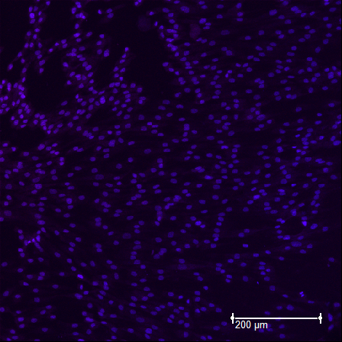
Fig. 2. CLSM images of photo hydrogel-PE 240 with human fibroblasts, stained with Phalloidin-TRITC (red) and Hoechst (blue). Bar 200 µm.

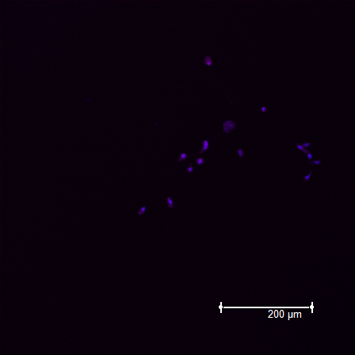
Fig. 3. CLSM images of photo hydrogel-Methyluracil with human fibroblasts, stained with Phalloidin-TRITC (red) and Hoechst (blue). Bar 200 µm.
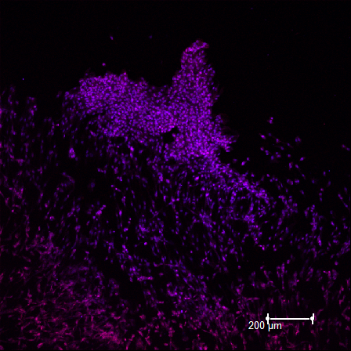
Fig. 4. CLSM images of photo hydrogel-Lecithin with human fibroblasts, stained with Phalloidin-TRITC (red) and Hoechst (blue). Bar 200 µm.
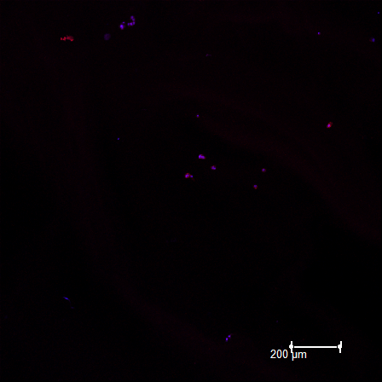
Fig. 5. CLSM images of photo hydrogel-PEI-M2 with human fibroblasts, stained with Phalloidin-TRITC (red) and Hoechst (blue). Bar 200 µm.

